Group 4

Dhruvi Jugalkishor Modi

Qiran Sun

Rojin Ghaderi

**ALY6010**

**Final Report for Toronto Airbnb**

**Introduction:**

Airbnb has become the go-to choice for travelers seeking unique and personalized accommodations. People like to compare the prices between traditional hotels and Airbnb. (Combs et al., 2020). Therefore we analyzed Toronto Airbnb for this project. The data we used comes from the “Inside Airbnb” and it contains summary information and metrics for listings in Toronto. The original data has 19276 rows and 18 columns. We will divide this project report into different sections which are summary data, hypothesis testing, and determining relationships between variables in the data.

In the first part, we have the data exploration analysis. Then for a deeper study, we are interested in comparing Toronto Airbnb to the fourth city on the rank of Tracel+Leisure Magazine which Vancouver Airbnb. By looking at the geographically, we decided to narrow down the area to downtown. We define the latitude and longitude boundaries in each downtown. These ranges are based on the provided information from multiple sources, including OpenStreetMap latitude. to, and latitudelongitude.org. After that, we used the filter function to select the listings within our target range.

**Summary of EDA:**

In the data cleaning process, we have employed several data preprocessing operations to clean the data and make it analysis-ready. Firstly, we have taken a subset of data frame that includes only the columns necessary for our analysis which include categorical and numerical variables followed by a summary to get an idea of the descriptive statistics of the data (Table 1in Appendix). We handled the ‘name’ column by splitting it into multiple columns ‘listing’, ‘rating’, ‘bedrooms’, ‘beds’, and ‘baths’. After checking for null values and dropping them we worked on extracting numerical values from the columns.

The visualizations for exploratory data analysis are in the Appendix.

The data analysis of Airbnb listings in Toronto(appendix figure 1) reveals a distinct distribution across four room types: Entire home/apartment, hotel room, private room, and shared room. The graphical representation highlights that the most prevalent category is the Entire home/apartment, boasting the highest number of listings. Conversely, the hotel room type is notably scarce, featuring only a single listing in the dataset.

The boxplot (appendix figure 2) represents the price range for each room type, and the median price is represented by blue dots.

We explored the relationship between price and various factors such as bedrooms, beds, baths, and ratings by constructing a correlation matrix (appendix figure 3). The findings indicate that price exhibits a weak correlation with these factors, as the correlation coefficients are in proximity to zero.

We generated an interactive map to understand the number of listings in various areas (appendix figure 4). Through this, we found that Central Toronto (i.e. Downtown Toronto) has the highest number of listings.

**Hypothesis Testing:**

**1. Comparison of prices in Toronto & Vancouver Downtown**

Through exploration, we found that Toronto Downtown has the highest number of listings. Then for a deeper study, we were interested in comparing Toronto Airbnb to the fourth city on the rank of Travel+Leisure Magazine which is Vancouver Airbnb. First of all, we would like to determine whether there is a significant difference in the average prices of property listings between Toronto Downtown and Vancouver Downtown. We employ a Two-sample test to compare the mean prices in this situation.

**Null Hypothesis(H0):** The average price of listings in Toronto and Vancouver downtown has no significant difference.

**Alternate Hypothesis(H1):** The average price of listings in Toronto and Vancouver downtown are statistically different.

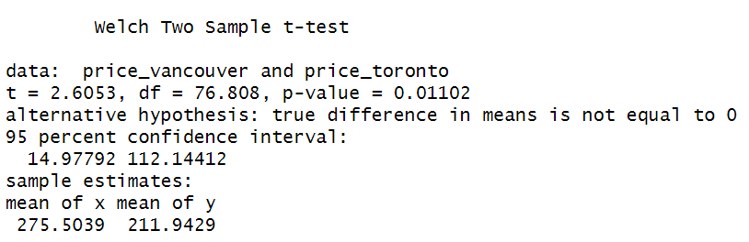

The outcomes of the t-test reveal a statistically significant difference in average listing prices between the downtown areas of Vancouver and Toronto. The t-statistic, standing at 2.6053, corresponds to a p-value of 0.01102. As the p-value falls below the common significance threshold of 0.05, we can reject the null hypothesis, signifying that the actual difference in means is not zero. The 95% confidence interval (14.97792 to 112.14412) for the disparity in means suggests, with 95% confidence, that the genuine distinction in average prices falls within this interval. This provides support for the assertion of a substantial variation in prices between the two locations which can also be seen in appendix figure 5.

**2. Comparison of ratings in Toronto & Vancouver Downtown**

After seeing the price comparison, we are interested in determining which city has a higher rating downtown. Therefore, we applied the Two-sample hypothesis test of the mean of 'rating' between two cities downtown. This test can help us compare the rating performance of different city Airbnb.

**Null Hypothesis (H0):** There is no significant difference in rating between downtown Toronto and downtown Vancouver Airbnb.

**Alternative Hypothesis (H1):** There is a significant difference in rating between the two groups.

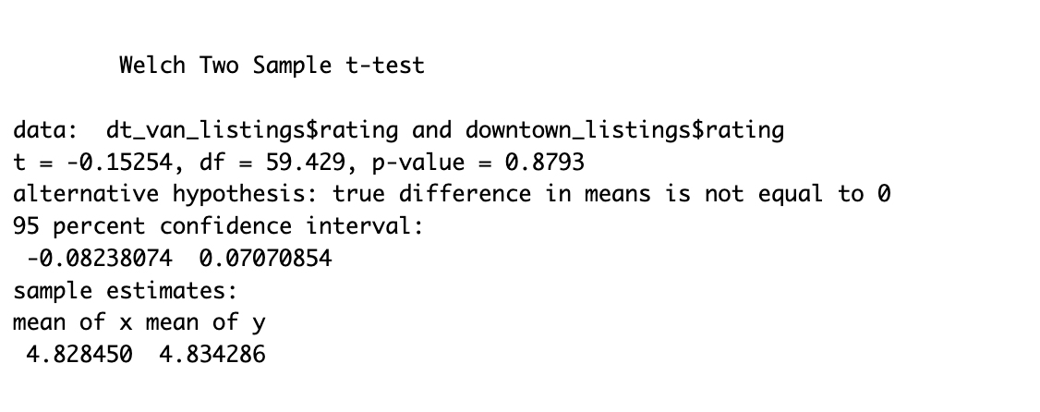

Here, the P value is 0.8793, which is greater than the common significance level of 0.05, there is insufficient evidence to reject the null hypothesis. The 95% confidence interval for the difference in means is between -0.0824 and 0.0707. Therefore, we do not have enough statistical evidence to claim a significant difference in average ratings between Vancouver and Toronto downtown listings.

Appendix figure 6 visualizes the t-test results. The image shows a box plot rating comparison between two cities’ Airbnb, Vancouver and Toronto. The median rating for Toronto is slightly higher than Vancouver's, sitting close to 4.7. The IQR for Toronto is wider than Vancouver's, with ratings ranging from around 4.6 to almost 4.8, suggesting greater variability in ratings for Toronto.

**3. Impact of proximity to CN Tower and distance from the city center on Airbnb pricing in Toronto​​**

Since there is no significant difference in the rating between the two cities downtown, we continued to focus on the Comparison of the prices based on distance from CN Tower since CN Tower is recognized as Toronto's primary landmark (Based on Narcity.com). So we wondered if the walkable distance to this landmark significantly influences Airbnb prices and affects tourists' decisions. A 1 km radius around these points was defined as the walkable distance, according to the “**Statistics Canada**” website.

**Null Hypothesis(H0):** It states that there is no difference in average prices between this group and the whole population.

**Alternative hypothesis(H1):** It claims that their average prices are significantly different.

The one-sample t-test yielded a statistic of 28.45 with a p-value of approximately 6.5*10-142, indicating a statistically significant difference in prices based on distance from CN Tower.

Also, we divided the dataset into two segments based on the median distance from Toronto's city center as the dividing line. The median distance is roughly 4.7 kilometers. Those within 4.7 km (group 1) and those beyond 4.7 km (group 2).

The outcomes of the test continue to reveal an extremely low p-value, signifying that there is a notable difference in the average prices between the two groups (appendix table 3 and figure 7).

**Identifying relationships between variables:**

**1. Impact of Host Experience on Airbnb Listing Prices: Analyzing Price Variation with Host Tenure**

Furthermore, based on the first and last review available in the Airbnb dataset we define The number of days between the first and last review was calculated to represent the host experience. By dividing number of reviews by reviews per month to find the approximate number of months that the host is working in Airbnb (reviews per month = number of reviews / number of month being in Airbnb) for this we consider only the listings that have been available up to recent months (2023) filter the data also based on the type of the room and then apply regression and scatterplot between prices and number of months working in Airbnb. We applied hypothesis testing to find the answer.

**Null Hypothesis:** There is no relationship between host experience and the pricing of Airbnb listings.

**Alternative Hypothesis:** There is a relationship between host experience and the pricing of Airbnb listings.

The process involves filtering data based on the last review date in 2023. A histogram (appendix figure 8) is then created to visualize the distribution of listings according to their distance from the city center, with 1 km steps aiding in identifying clusters of similar-priced listings. The analysis continues by filtering listings within 1 to 2 km from the city center and creating a bar chart (figure 9) to depict the distribution of room types within this distance range. This step provides insights into the prevalence of different room types in the specified area.

The test results (table 4 ) were:

* R-squared: 0.027​​
* Intercept (Baseline Price): 252.9955​​
* Coefficient (Host Experience): -0.0231​

The analysis revealed a negative correlation between host experience and price, but it explains only a small fraction of the variability in pricing. The findings suggest that more experienced hosts might slightly lower their prices. However, host experience is not the primary factor influencing Airbnb pricing (Appendix Figure 10).

**2. Does the change in availability impact the prices?**

We are also curious about whether the change in the availability of Airbnb impacts the prices.

**Null Hypothesis (H0):** There is no significant correlation between availability and price.

**Alternate Hypothesis (H1):** There is a significant correlation between availability and price.

From regression testing we obtained an R-squared value of 0.001988 which is very low (0.001988), suggesting that the model explains only a small proportion of the variability in the prices.

The scatterplot of availability vs price (appendix figure 11). suggests a lack of correlation between the two variables. The horizontal regression line indicates the absence of a noticeable slope in the regression line indicating that there is no linear relationship between the variables. The points are spread randomly, suggesting that changes in availability do not correspond to changes in the price.

**3. Host listings count vs overall rating of Airbnb listings in downtown Toronto**

After seeing the price, we would like to see whether the more hosts listed on Airbnb have better ratings or not. The purpose is to test whether there's a statistically significant correlation between the calculated host listings count and the overall rating of Airbnb listings in downtown Toronto. We use Pearson’s product-moment correlation which is “the most common way of measuring a linear relationship between two variables[(Scribbr,n.d.)].”

**Null Hypothesis (H0):** There is no significant correlation between the calculated host listings count and the overall rating.

**Alternative Hypothesis (H1):** There is a significant correlation between the calculated host listings count and the overall rating.

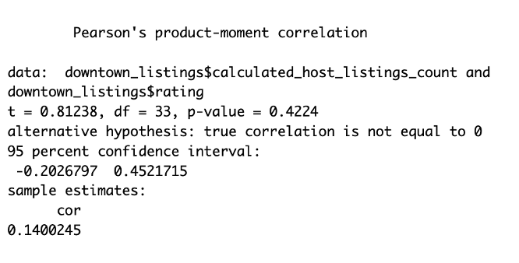

Since the p-value is 0.4224, which is greater than the commonly used significance level of 0.05, we do not have enough evidence to reject the null hypothesis. The null hypothesis in this context is that there is no correlation between calculated_host_listings_count and rating. Therefore, based on this analysis, we do not find a statistically significant correlation between these two variables. The correlation coefficient is small (0.14), and the confidence interval includes zero, further supporting the lack of a significant correlation.

The scatter plot (Appendix Figure 12) does not show a clear or strong pattern indicating a linear relationship between the number of listings a host has and the average rating. The regression line suggests there may be a slight positive trend, meaning that as the number of listings increases, the rating also increases, but this trend is not strongly pronounced.

There are several data points clustered at the lower end of the host listings count, which suggests that most hosts have a small number of listings. The ratings for these hosts vary across the scale. There are fewer hosts with a large number of listings, and while their ratings also vary, the line of best fit suggests that on average, their ratings might be slightly higher.

**Conclusion**

When considering Airbnb rentals, an intriguing observation emerges: lodging in Downtown Vancouver proves to be more costly than in Downtown Toronto, defying initial expectations. Notably, this price disparity does not appear to correlate directly with the abundance of available rental options; an increased supply does not necessarily drive prices down. Remarkably, guest satisfaction levels remain consistent between the two locations, indicating that the volume of choices does not significantly influence overall experiences.

Interestingly, proximity to the CN Tower in Toronto incurs higher costs, underscoring the pivotal role of location in pricing dynamics. Another noteworthy finding is that the presumed correlation between host experience and pricing does not consistently hold true. In some instances, newer hosts command comparable rates, suggesting that factors such as amenities and unique features may wield greater influence over pricing decisions.

Surprisingly, the quantity of listed hosts does not markedly impact guest ratings, challenging the assumption that a higher number of options leads to better overall satisfaction. Consequently, the Airbnb rental landscape in both Vancouver and Toronto appears more nuanced than a simple equation of abundant choices or seasoned hosts. Multiple factors, including location, amenities, and host characteristics, collectively contribute to the intricate dynamics of the rental experience.

**References**

1. Combs, J., Kerrigan, D., & Wachsmuth, D. (2020). Short-term rentals in Canada: Uneven growth, uneven impacts. Canadian Journal of Urban Research, 29(1), 119–134. <https://www.jstor.org/stable/26929901>

2. Hahn, N. (2020, July 31). Making maps with R. 6 leaflet. <https://bookdown.org/nicohahn/making_maps_with_r5/docs/leaflet.html>

3. Leaflet for R - colors. (n.d.). <https://rstudio.github.io/leaflet/colors.html>

4. to use strsplit() function in R? | DigitalOcean. (n.d.). Www.digitalocean.com. <https://www.digitalocean.com/community/tutorials/strsplit-function-in-r>

5. Unnest a list-column into columns — unnest_wider. (n.d.). Tidyr.tidyverse.org. <https://tidyr.tidyverse.org/reference/unnest_wider.html>

6. Educative Answers - Trusted Answers to Developer Questions. (n.d.). Educative. Retrieved November 11, 2023, from <https://www.educative.io/answers/what-is-the-grepl-function-in-r>

7. Radečić, D. (July 14, 2022), How to Make Stunning Boxplots in R: A Complete Guide to ggplot Boxplot. Retrieved from Appsilon: <https://appsilon.com/ggplot2-boxplots/>

8. Visualize correlation matrix using correlogram - Easy Guides - Wiki - STHDA. (n.d.). [Www.sthda.com](http://www.sthda.com).

<http://www.sthda.com/english/wiki/visualize-correlation-matrix-using-correlogram>

9. Cantrell, L. (2023, July 11). The 5 best cities in Canada, according to Travel + Leisure Readers. Travel + Leisure.

<https://www.travelandleisure.com/best-cities-in-canada-2023-7510784>

10. Latitude. to. (n.d.). Find GPS coordinates for the world’s countries. <https://latitude.to/map>

11. Toronto, ON, Canada. Lat Long Finder. (n.d.).

<https://www.latlong.net/place/toronto-on-canada-27230.html>

12. Basa, E. (2017, April 6). 17 Toronto landmarks you must visit at least once in your life. Narcity. Retrieved from

<https://www.narcity.com/toronto/17-toronto-landmarks-you-must-visit-at-least-once-in-you>

13. Statistics Canada. (2021). Defining Canada’s Downtown Neighbourhoods: 2016 Boundaries. Retrieved from

<https://www150.statcan.gc.ca/n1/pub/91f0015m/91f0015m2021001-eng.htm>

14. ZACH. (August 3, 2022). How to Perform a Two Sample T-Test in R. Statology, Retrieved from www.statology.org

15. Turney, S. (2023, June 22). *Pearson correlation coefficient (R): Guide & examples*. Scribbr. <https://www.scribbr.com/statistics/pearson-correlation-coefficient/>

**APPENDIX:**

| | **Column name** | **Descriptive Statistics** | | | --- | --- | --- | | **Latitude** | *Minimum* | 43.59 | | *1st Quartile* | 43.65 | | *Median* | 43.67 | | *Mean* | 43.68 | | *3rd Quartile* | 43.71 | | *Maximum* | 43.84 | | **Longitude** | *Minimum* | -79.62 | | *1st Quartile* | -79.43 | | *Median* | -79.40 | | *Mean* | -79.40 | | *3rd Quartile* | -79.37 | | *Maximum* | -79.13 | | **Price** | *Minimum* | 13 | | *1st Quartile* | 80 | | *Median* | 129 | | *Mean* | 194.3 | | *3rd Quartile* | 222 | | *Maximum* | 13706 | | | **Column name** | **Descriptive Statistics** | | | --- | --- | --- | | **Minimum Nights** | *Minimum* | 1 | | *1st Quartile* | 3 | | *Median* | 28 | | *Mean* | 25.4 | | *3rd Quartile* | 28 | | *Maximum* | 1125 | | **Availability 365** | *Minimum* | 0 | | *1st Quartile* | 2 | | *Median* | 121 | | *Mean* | 148.8 | | *3rd Quartile* | 273 | | *Maximum* | 365 | |
| --- | --- | --- | --- | --- | --- | --- | --- | --- | --- | --- | --- | --- | --- | --- | --- | --- | --- | --- | --- | --- | --- | --- | --- | --- | --- | --- | --- | --- | --- | --- | --- | --- | --- | --- | --- | --- | --- | --- | --- | --- | --- | --- | --- | --- | --- | --- | --- | --- | --- | --- | --- | --- | --- | --- | --- | --- | --- | --- | --- | --- | --- | --- | --- | --- | --- | --- | --- | --- | --- | --- | --- | --- |

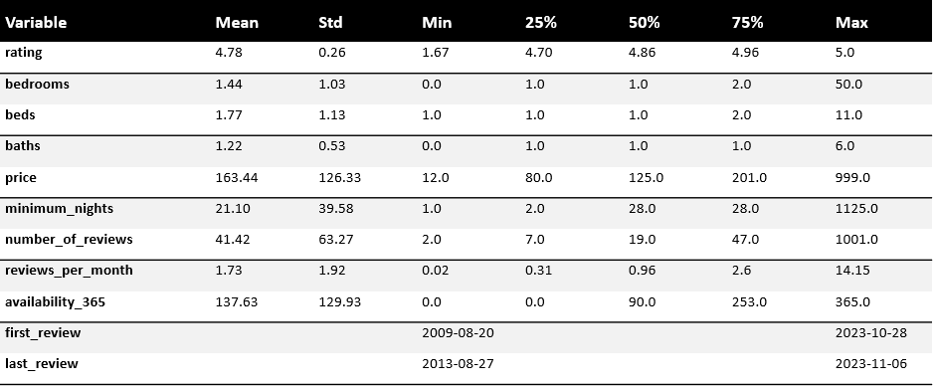

Table 1 Descriptive Statistics Table

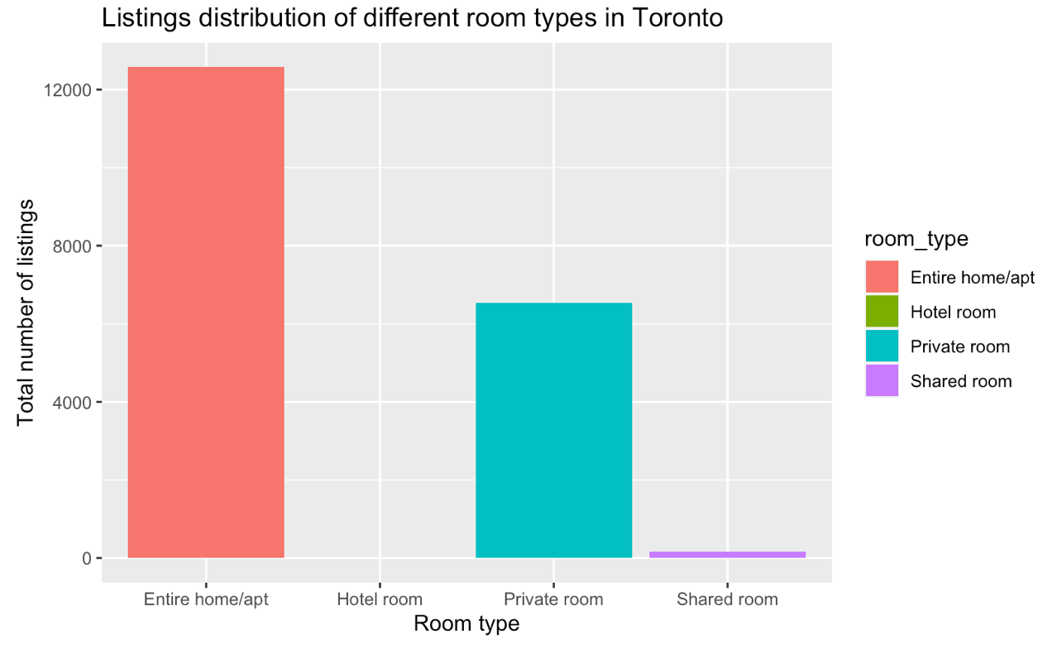

Figure 1

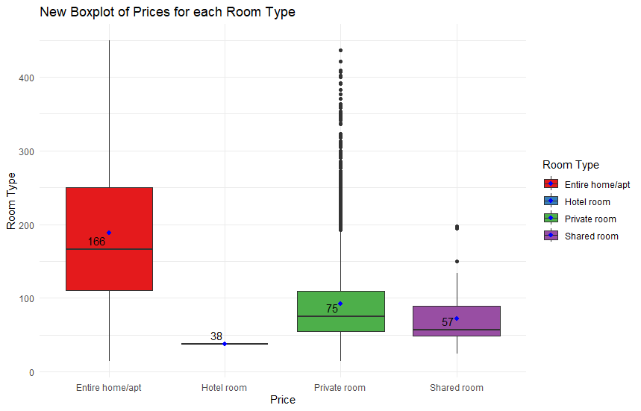

Figure 2

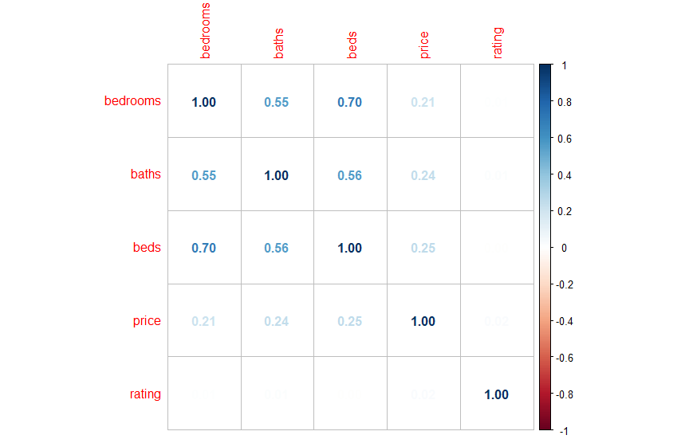

Figure 3

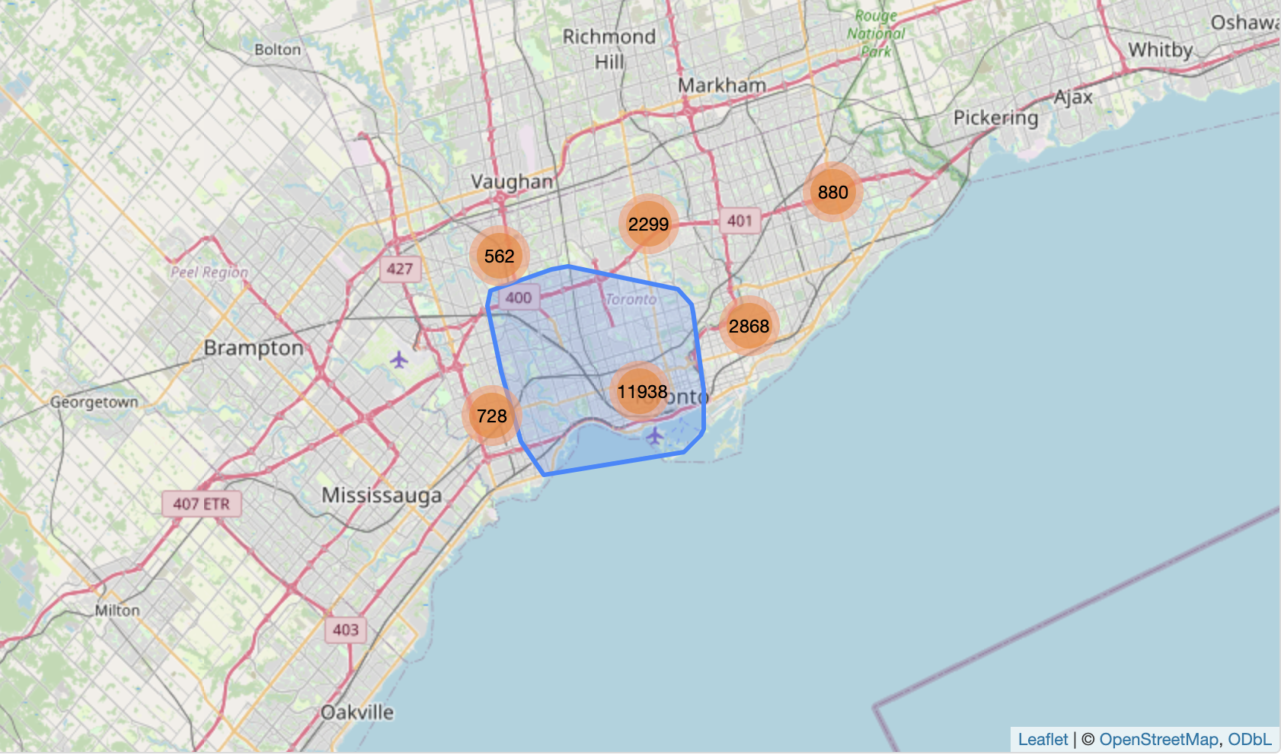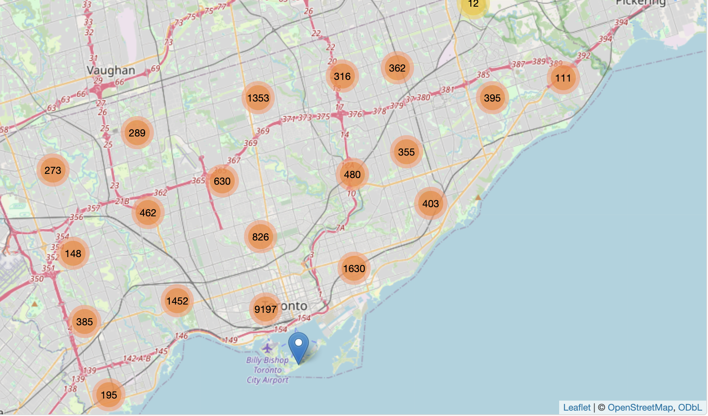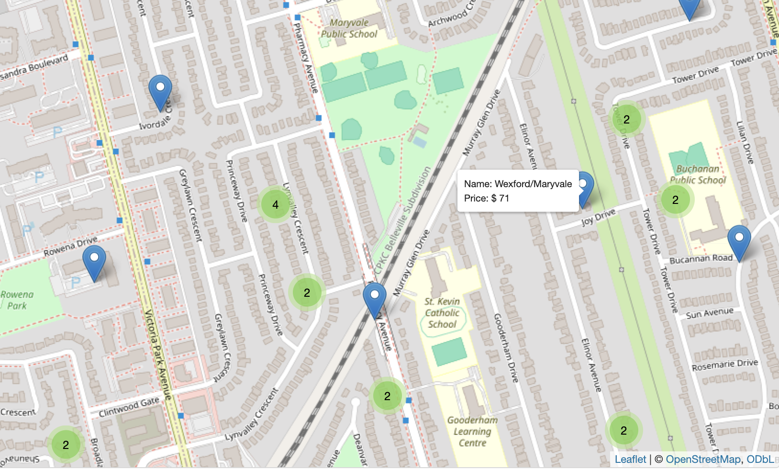

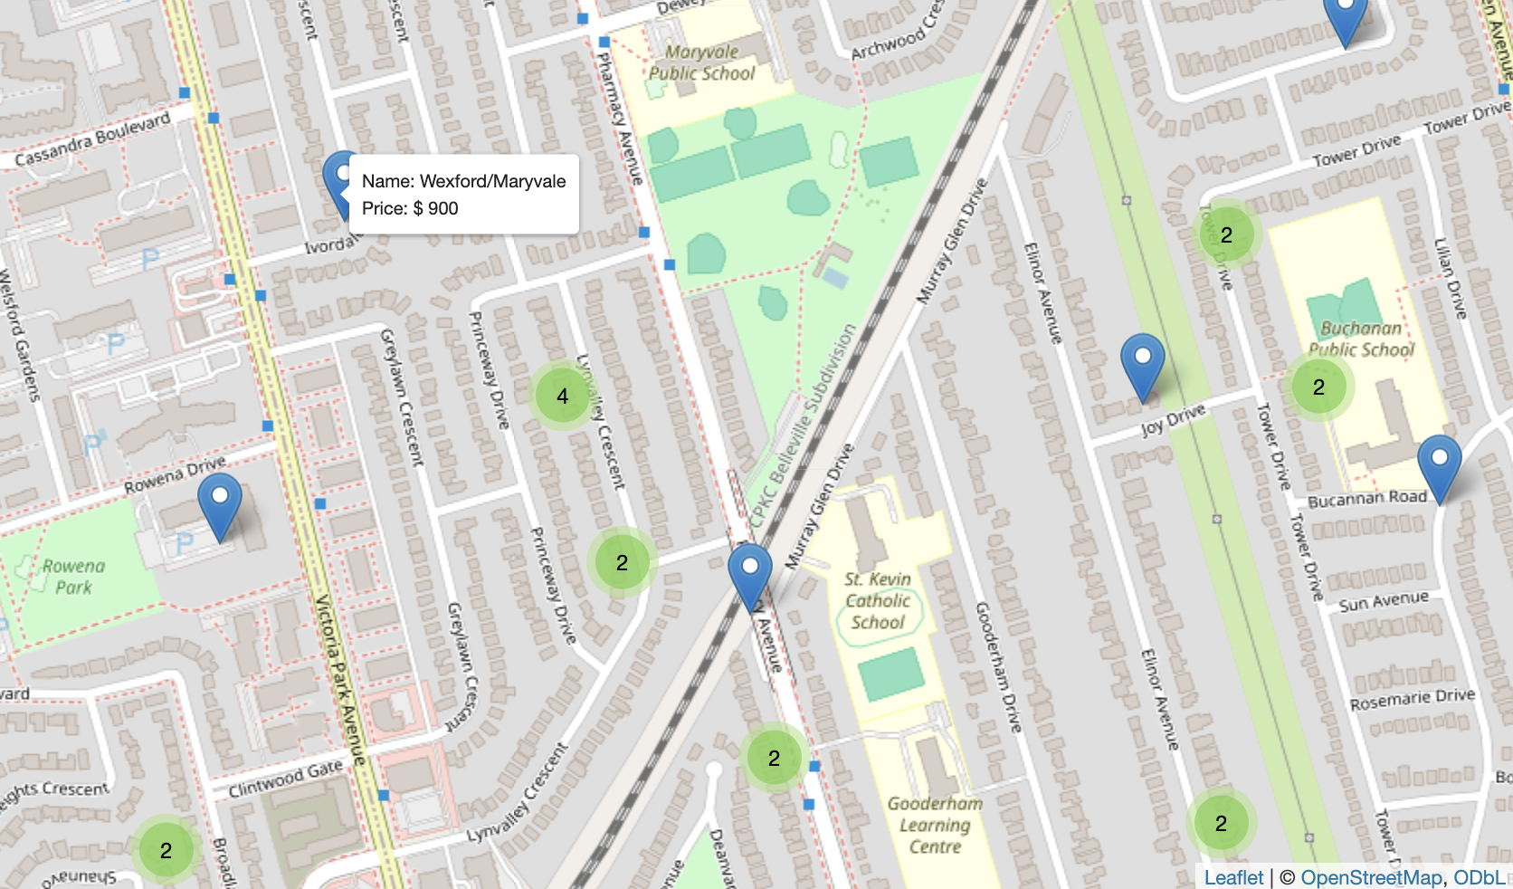

Figure 4

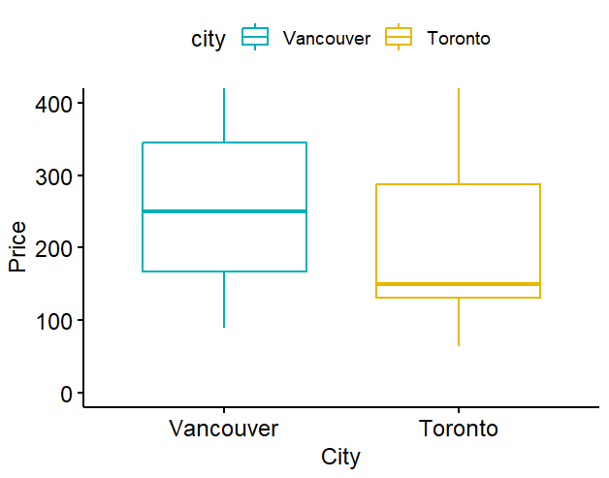

Figure 5

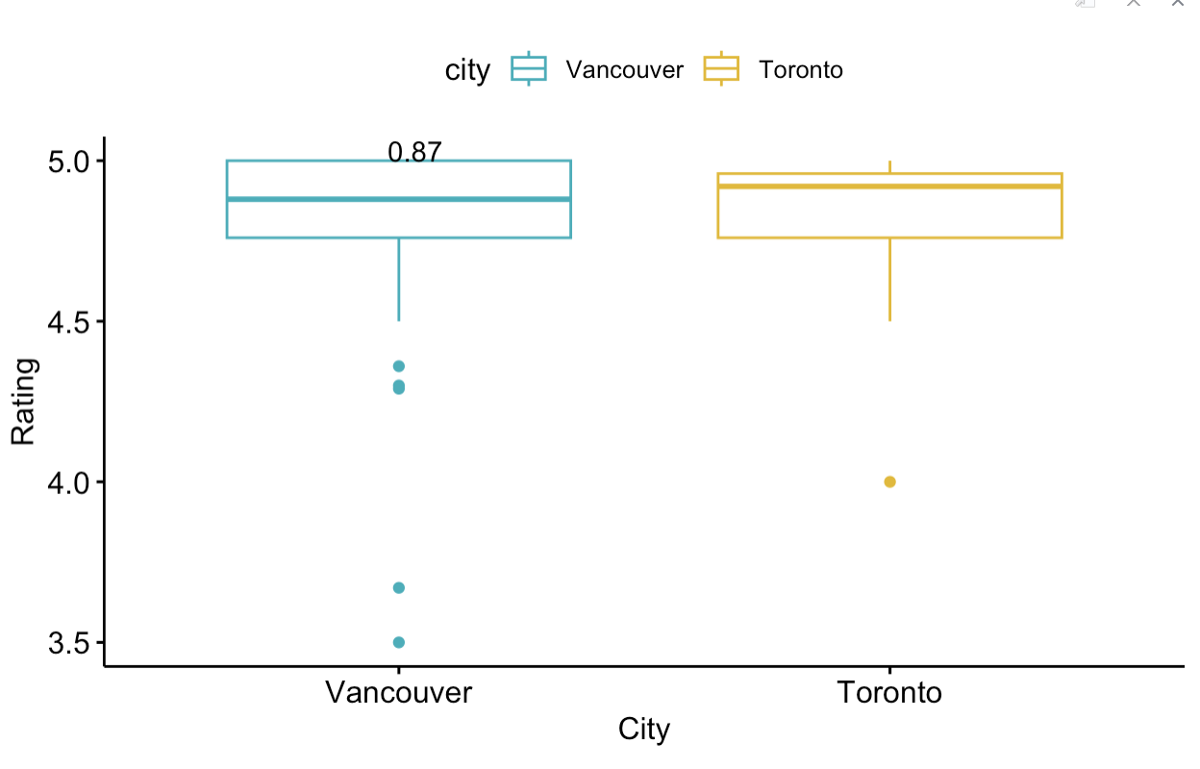

Figure 6

Table 2 - One-Sample T-Test

| **t-statistic** | **p-value** | **Estimate mean** |
| --- | --- | --- |
| 28.45 | 6.5*10-142 | 226.1073 |

Table 3- Two-Sample T-Test – Median distance as dividing line

| **t-statistic** | **p-value** | **Mean difference** | **Estimate group 1** | **Estimate group 2** |
| --- | --- | --- | --- | --- |
| 33.29 | 1.7*10-231 | 57.05 | 183 | 125.94 |

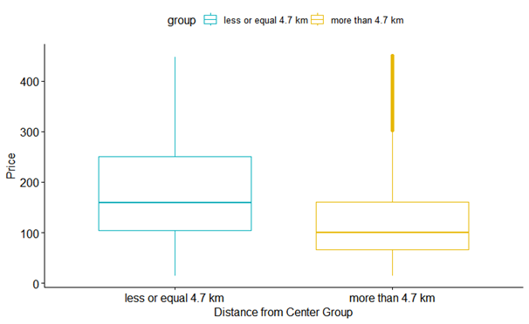

Figure 7

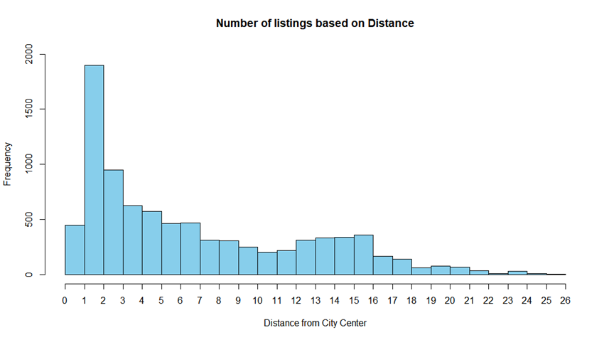

Figure 8 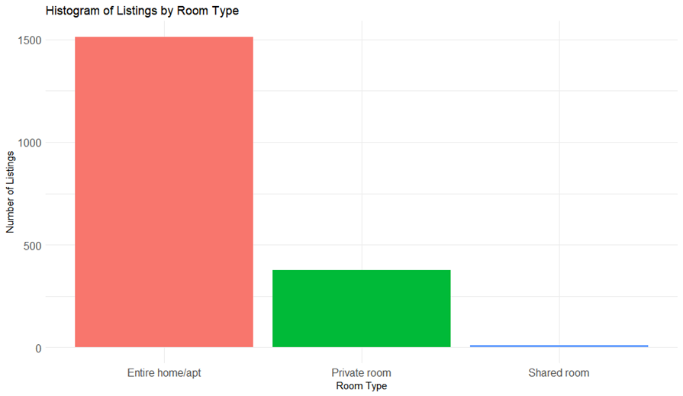

Figure 9

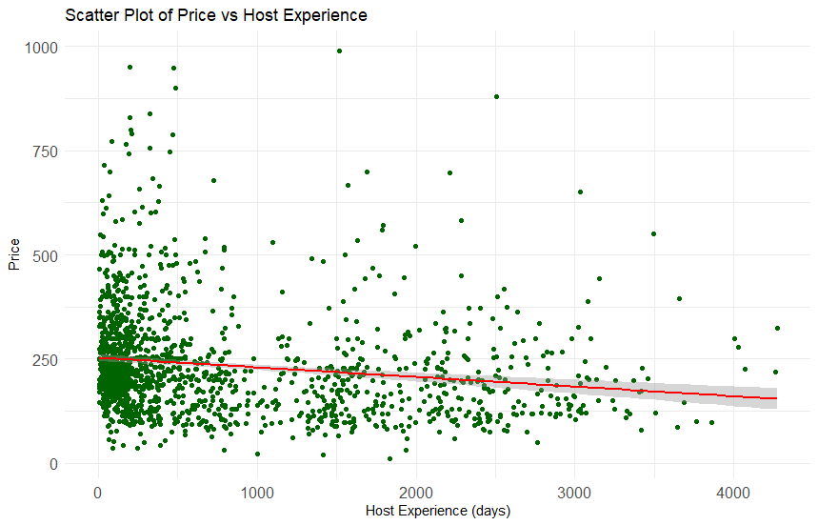

Figure 10

Table 4 – Regression model summary

| **Residuals** | | | | |
| --- | --- | --- | --- | --- |
| **Minimum** | **First quartile** | **Median** | **Third quartile** | **Maximum** |
| -213.87 | -78.74 | -27.68 | 45.81 | 769.95 |
| **Coefficients** | | | | |
|  | **Estimate** | **Stand. Error** | | **p-value** |
| **Intercept** | 253.9955 | 4.309 | | 2*10-16 |
| **Host Experience** | -0.0231 | 0.004 | | 1.48*10-10 |
| **R2** | 0.027 | | | |

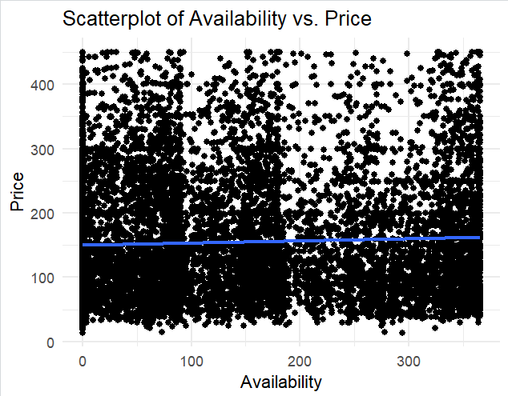

Figure 11

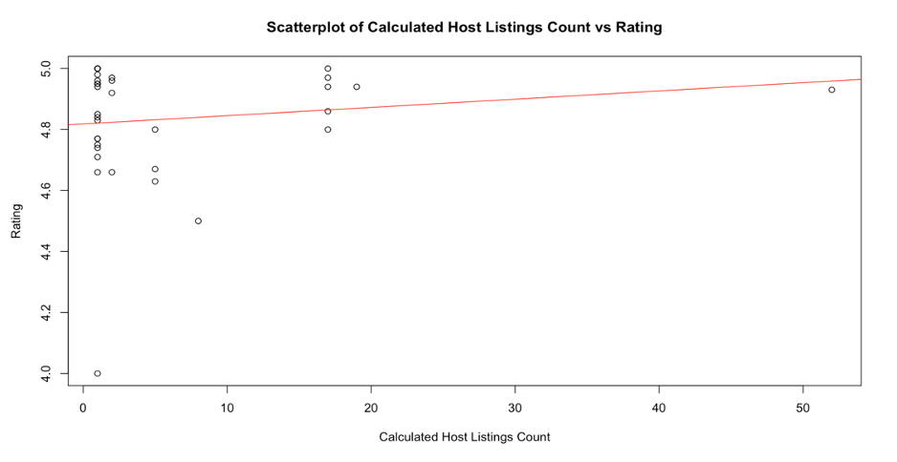

Figure 12